Emergency Procedure – Ski Club Holiday Park

In the event of an emergency, please follow these steps calmly and promptly:

# Assist Anyone in Immediate Danger

* + Only help if it is safe to do so.
  + Do not put yourself or others at unnecessary risk.

# Raise the Alarm

* + **Call Emergency Services – 000 Police, Fire, Ambulance**
  + Provide:
    - Your name
    - Location: *156 Melbourne Street Mulwala 2647*
    - Nature of the emergency
    - Nearest cabin or landmark

# Notify Park Management

* + **Reception:** 03 5744 1050
  + **After Hours/Emergency Contact from 11pm:** (03) 5742 1299

# Evacuation

* + If instructed to evacuate or in the case of fire or gas leak:
    - Leave your belongings behind.
    - Follow marked evacuation routes to the **Emergency Assembly Point** (see park map).
    - Do not return until cleared by emergency personnel or management.

North

Pro Shop 10m

Boat trailer parking

**1**

Sandpit

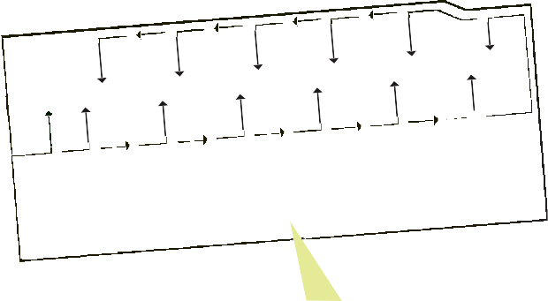Laundry

Entrance

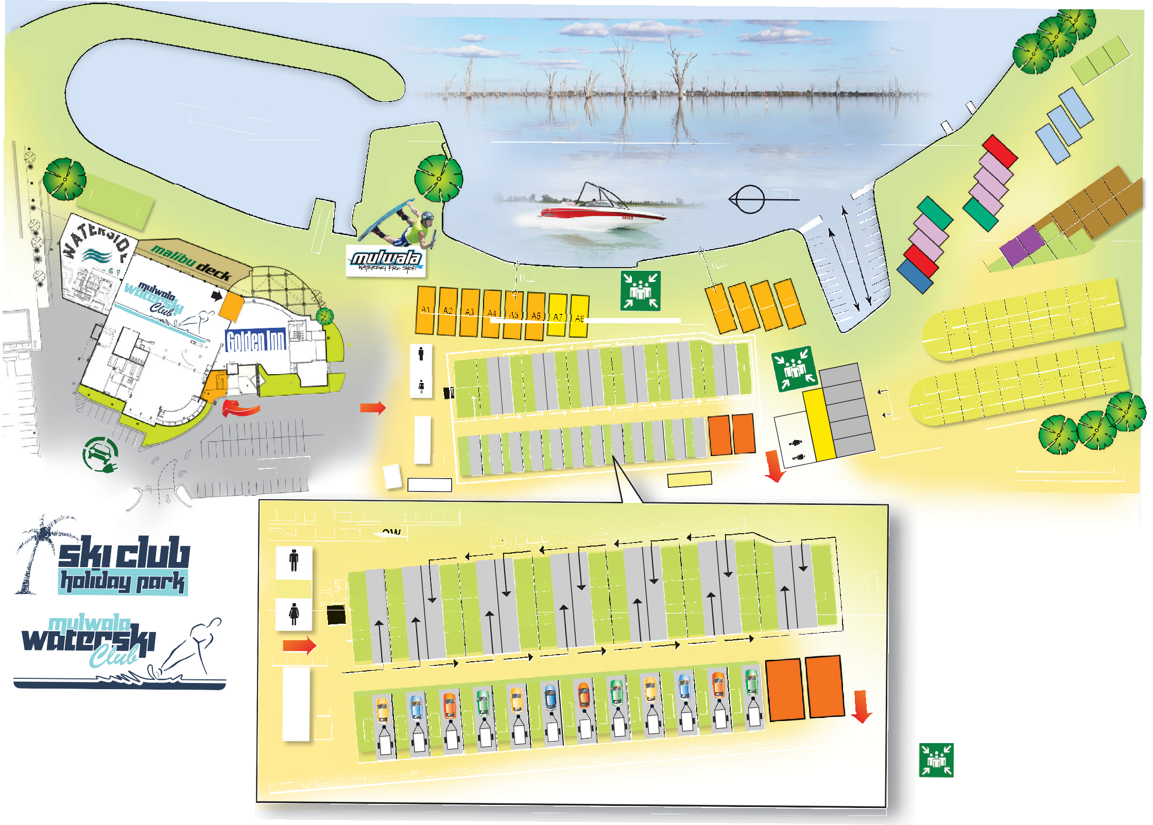

[**www.lakemulwala.com.au**](http://www.lakemulwala.com.au/)

156 Melbourne St, Mulwala NSW 2647

Phone: (03) 5744 1050

Ski Club (03) 5744 1888

**Emergency After Hours (from 11pm) Contact (03) 5742 299**

Clothesline

**C ps et — c nd in p**

Laundry

r

Distance from toilet blocks to sites is not more than 80 metre

 3 bedroom Waterfront Apartments

 2 bedroom Waterfront Apartments

 2 bedroom Waterfront Apartments

 3 bedroom High Rise Apartments

 1 bedroom Waterfront Cabins

 4 berth Waterfront Cabins

 5 berth Waterfront Cabins

 Waterfront Villas

 Budget Cabins

 Standard Cabins

 Powered Sites

 Annual Sites

**Emergency Assembly Areas 1 & 2**